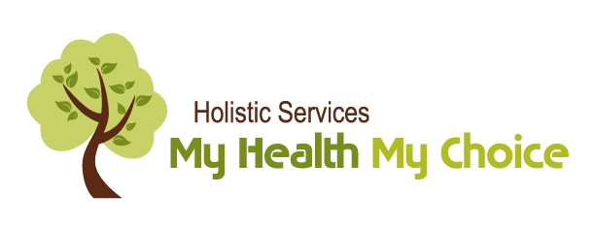

THE KITCHESSIPI JOURNEY: HEALING WATER

The Kitchessipi Journey started as an inspiration from Guru Ram Das ji, the holder of the throne of Raj yoga. He embodies the energy of compassion, love and healing in the Universe. The unique and uplifting project was to unfold during a Yatra to India in October 2018. However, the universe had a different plan for me and this water healing journey. Start at home it said.
This journey thus stems from the Divine guidance of love, of healing and of our precious water element. The dance of the water element can take many shapes and forms, from cleanings, overpowering, emotions, cellular, bodily functions, birth and death and indeed from nature’s lens.
Water colours our vision of the world – ‘go with the flow’, ‘stuck in the mud’, stagnate and pool’. This journey creates movement – of thought, of breath, of body – to create ease like the free running waters of the Himalayas.
Water is the thread that carries us during this awakening of the inner healer journey. It supports the human spirit in knowing that anything is possible when the Mind is overcome by the gift of letting go. We create inner harmony and union through Kundalini yoga deep meditation and sound current practiced along these waters of our golden, elevating journey.
The drops of time are like ripples upon the ocean of our Mind. This voyage about love – of self, of others and the elements - rekindle that remembrance of our Divine Self and our deep connection to Nature. With calm Mind, we give back Love to Mother Earth and her waters.

Join Meherbani Kaur for the full 10-day meditation or for one day. It is all about community, where one positive intention grows into an assembly of transforming actions.
Come celebrate this journey at the Humanics Sculpture Sanctuary in Cumberland. We will come together and celebrate the healing of our waters and of ourselves.

THE PROGRAM

Wednesday July 4th Day 1 of the Awakening the Inner Healer meditation – Shushumna –
Studio Meherbani (2706 Old Montreal Road, Cumberland) at 9:30 am and Rama Lotus Yoga Centre (342 Gladstone Ottawa) noon

Thursday July 5th Day 2 of the Awakening the Inner Healer meditation – Ida –
Studio Meherbani 9:30am

Friday July 6th Day 3 of the Awakening the Inner Healer meditation – Pingala –Studio Meherbani 9:30 am

Saturday July 7th Day 4 of the Awakening the Inner Healer meditation – Kauri Kriya –
On own

Sunday July 8th Day 5 of the Awakening the Inner Healer meditation – Kauri Kriya –
on own

Monday July 9th Day 5 of the Awakening the Inner Healer meditation – Kauri Kriya –
We will begin the meditation at Rama Lotus Yoga Centre at noon then please continue on your own

Tuesday July 10th Day 6 of the Awakening the Inner Healer meditation – Kauri Kriya –
on own

Wednesday July 11th Day 7 of the Awakening the Inner Healer meditation – Kauri Kriya –
We will begin the meditation at Rama Lotus Yoga Centre at noon then please continue on your own

Thursday July 12th Day 8 of the Awakening the Inner Healer meditation – Kauri Kriya –
on own

Friday July 13th Day 9 of the Awakening the Inner Healer meditation – Kauri Kriya –
on own

Saturday July 14th Day 10 of the Awakening the Inner Healer meditation – Kauri Kriya –
The Kitchessipi Journey: Water Healing Kundalini Yoga and Shamanic Ceremony with special meditation, live chanting kirtan and triple gong event on Saturday July 14th from 1-4pm
35$ includes Sculpture Sanctuary entrance fee (3486 Old Montreal Road, Cumberland

Program for July 14th event 1-4 pm
Welcome and introductions
Why Kitchessipi Journey?
TUNE IN
Yoga and part of Kauri Kriya
Relaxation with 3 gongs
Breathwalk to site of ceremony
Shamanic Water healing ceremony
Kirtan with Sounds of the Heart Jatha (group)
Refreshments and snacks and sharing as a community

SEE SEPARATE PDF OF FULL AWAKENING THE INNER HEALER 10-DAY MEDITATION

